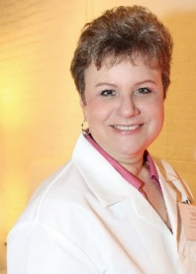

Alexandra Kowcz
UV Index Scientific Experts
Chief Scientist & Executive Vice President, Science

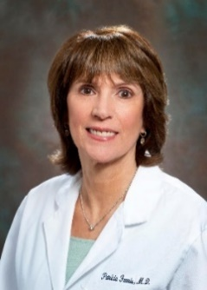

Patricia K. Farris, M.D.
Cosmetic Dermatologist

Committed to Safety. Driven by Science.

Alexandra Kowcz is chief scientist for the Personal Care Products Council (PCPC), overseeing PCPC’s scientific programs, technical committees and publications, and serves as the industry’s scientific liaison for domestic and international organizations.

She joined PCPC in 2018 after serving as vice president of U.S. Research
& Development at Beiersdorf, Inc., which manufactures personal care
brands, including Nivea, Eucerin and Aquaphor. She holds degrees in
biology and chemistry from Fairfield University, completed graduate
projects at Boston College and received her M.B.A. from the University
of Connecticut. She is an active member of the Society of Cosmetic
Chemists and the American Academy of Dermatology.

Dr. Patricia Farris is co-founder of the Science of Skincare Summit, a meeting dedicated exclusively to teaching aesthetic professionals about topical skincare and its use in clinical practice. She is a member of the teaching faculty at Tulane and maintains a private practice focusing on nonsurgical facial rejuvenation using dermal fillers, neurotoxins and energy-based devices.

Dr. Farris graduated from Tulane University School of Medicine and she is a Fellow of the American Academy of Dermatology and the American Society for Dermatologic Surgery.

Kimberly Norman, Ph.D.,
DABT, ERT
Senior Director, Safety, Regulatory and Toxicology
Kim Norman is senior director, Safety, Regulatory and Toxicology, at the Personal Care Products Council (PCPC). Prior to joining PCPC, she was associate research fellow – Global Product Stewardship and prior to that senior scientist – Product Stewardship at Burt’s Bees.
Norman received her Ph.D. in cell and developmental biology from Vanderbilt University.

